HOME LAB WRITE-UP

Mapping Active Directory Attack Paths with BloodHound
A hands-on lab: building, collecting, and visualizing a privilege-escalation path in an isolated environment
Type | Personal home lab exercise / portfolio write-up
Environment | Fully isolated, host-only networking
Tools | BloodHound Community Edition, SharpHound v2.13.0, VirtualBox, Windows Server 2022, Kali Linux
Focus | Active Directory attack-path analysis (offensive tooling, defensive value)
Status | Completed – full attack path collected and visualized

Contents
Contents 2
1. Overview 3
2. Objective and Scope 3
2.1 What the lab set out to do 3
2.2 Scope and safety 3
3. Background: What BloodHound Does 4
4. Method and Results 4
4.1 The attack path 4
4.2 Collection with SharpHound 5
4.3 Ingestion 5
4.4 The result: the full attack path visualized 6
5. Challenges and How They Were Solved 7
5.1 The root cause: memory starvation 7
5.2 A silent configuration rollback 8
5.3 Smaller frictions (each a quick lesson) 8
6. Why This Matters for Defenders 9
6.1 The blue-team case 9
6.2 From a snapshot to continuous monitoring 9
7. Conclusion and Next Steps 9

1. Overview
This write-up documents a personal home-lab exercise that set out to answer a practical question: how does a low-privileged user account quietly become a domain administrator, and how do we see it before an attacker does? To answer it, I built a small Active Directory (AD) domain from scratch in an isolated lab, deliberately planted a realistic chain of misconfigurations, and used BloodHound to collect and visualize the resulting attack path.
The core result is a single, clear picture: a powerless test user (analyst01) can reach full Domain Admins privileges in three hops, using nothing but legitimate, intended AD permissions. No exploit, no malware. Just access that piled up and connected in a way nobody intended – exactly the kind of drift that accumulates in real environments over years.
Key takeaway
BloodHound does not "hack" anything. It maps existing permissions and reveals dangerous chains that are invisible in a normal, list-by-list review. That makes it as valuable for defence (blue team) as it is for offence. The same map an attacker would use to find a way up, defenders can use to find and cut those chains first.

One point of full transparency, because it is part of the value of this write-up: the lab took substantially longer than planned. The AD build and the concept were straightforward; the friction came almost entirely from the lab environment itself – memory limits, tooling quirks, and a subtle configuration rollback. Section 5 documents these honestly, because the troubleshooting is itself reusable knowledge.

2. Objective and Scope

2.1 What the lab set out to do
- Understand what BloodHound is and how AD attack paths actually form.
- Build a controlled AD domain and craft one complete attack path by hand, so that every edge in the final graph maps to a specific, understood misconfiguration.
- Run the full offensive workflow end to end: collect with SharpHound, ingest into BloodHound, and visualize the path.
- Draw out the defensive lesson that makes this valuable to a blue team.

2.2 Scope and safety
All work was performed in a personal home lab, fully contained. This was a deliberate, non-negotiable constraint from the outset.
- Isolation: both virtual machines ran on a host-only / internal network. The AD target never had internet access during collection.
- No production systems: nothing in this lab touched any live infrastructure or real credentials. The lab domain (lab.local) is entirely fictional.
- Authorization first: BloodHound’s own documentation states it must never be used on systems you do not own or lack explicit permission to audit. Any use against a real environment would require written authorization and appropriate sign-off before collection.

3. Background: What BloodHound Does
Think of a large organization where thousands of people hold keys to different rooms. Some can open other people’s offices; some can copy keys; a few can reach the room where the master key is kept. Nobody planned it that way – it accumulated as people were granted access to do their jobs.
BloodHound draws the map of all those keys and who holds them. Once it is a map, finding a route from a nobody account to full control becomes a shortest-path problem. In AD terms, the "rooms and keys" are user accounts, groups, and permissions; BloodHound models them as a graph of nodes (users, groups, computers) and edges (relationships like "member of" or "can reset password of").
The one idea worth remembering
Every edge in an attack path is a legitimate, intended AD feature. The danger is not any single permission – it is the chain. That is why these paths are so common and so easily missed: each link looks normal on its own.

4. Method and Results
The exercise ran in five stages: build the domain, plant the path, collect, ingest, and visualize. I built the path by hand rather than using an automated seeding tool, specifically so I could tie each edge in the final graph to the exact command that produced it – which matters if findings ever need to be explained to others.

4.1 The attack path
The target chain, from powerless foothold to full compromise:
analyst01 ─ ForceChangePassword ─▶ it.helpdesk
─ MemberOf ─▶ Helpdesk Team ─ MemberOf ─▶ Domain Admins

Read in plain English: a nobody account can reset the password of a helpdesk account; that helpdesk account is (accidentally) nested inside Domain Admins. Reset the password, log in as the helpdesk user, and you own the domain.
Hop | Edge type | How it was created | Why it is dangerous
1 | ForceChangePassword | Granted analyst01 the "Reset Password" right over it.helpdesk (dsacls) | Lets a low-priv user take over another account without knowing its password
2 | MemberOf | Added it.helpdesk to the "Helpdesk Team" group | Ordinary on its own – rarely gets a second look
3 | MemberOf | Nested "Helpdesk Team" inside Domain Admins | Silently makes every group member a domain administrator

Before ever opening BloodHound, I confirmed the chain was real using AD’s own recursive group lookup. Because it.helpdesk appears in a recursive Domain Admins query despite not being a direct member, the nesting genuinely resolves to the top.
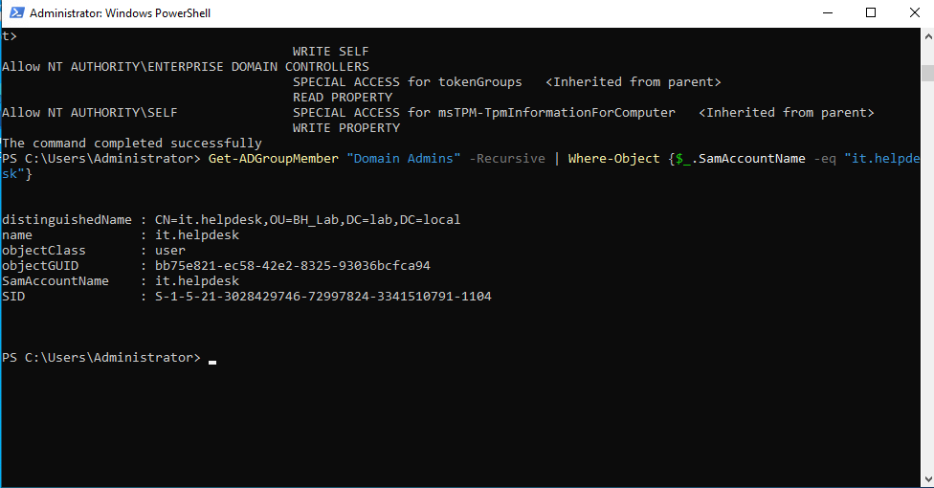
Figure 1 – AD confirms the path independently: it.helpdesk resolves as a recursive member of Domain Admins.

4.2 Collection with SharpHound
With the domain built, I ran SharpHound (the official collector) from the domain-joined Windows Server, using the "all" collection method so that ACL data – which carries the ForceChangePassword edge – was included. Collection completed in seconds and produced a single ZIP of JSON files (301 objects).
Verify before you trust
A lesson worth institutionalizing: after collection I did not transfer blindly. I extracted the ZIP and searched the JSON for the ForceChangePassword right, confirming the critical edge was actually present in the data before spending time ingesting it. This one check would have saved hours earlier in the lab (see Section 5).

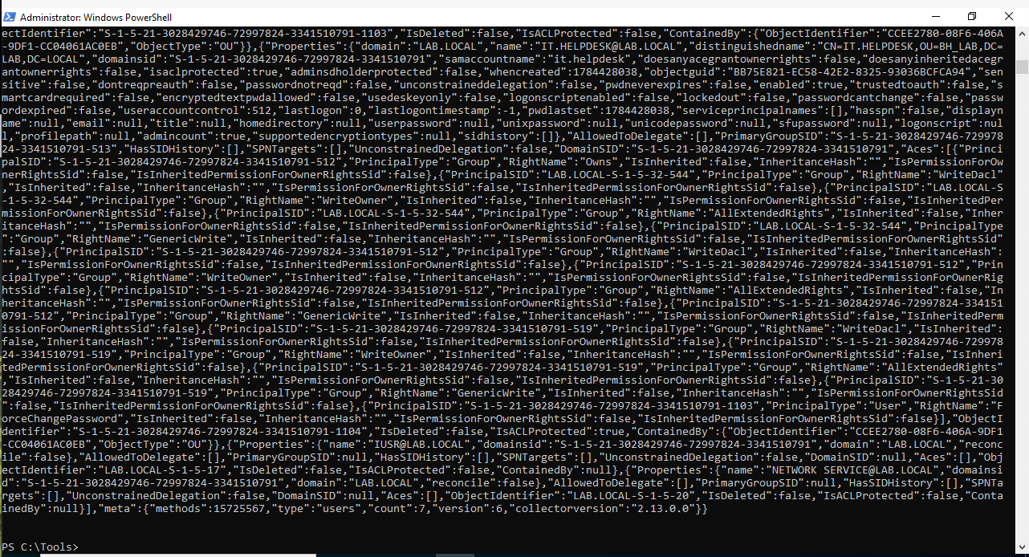
Figure 2 – Confirming the ForceChangePassword ACE is present in the collected data (PrincipalType: User → it.helpdesk) before transfer.

4.3 Ingestion
The ZIP was transferred to the Kali box (running BloodHound in Docker) over the isolated network via SSH, then ingested. A successful ingest job shows all seven files processed with zero failures.
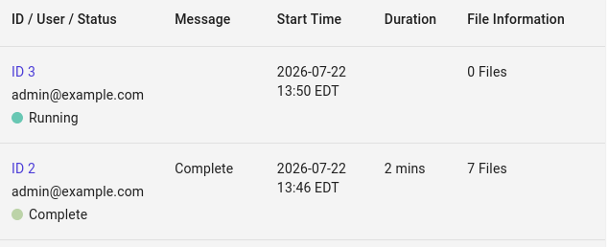
Figure 3 – A clean ingest: status Complete, 7 files, 0 failures.

4.4 The result: the full attack path visualized
With the data ingested, BloodHound’s pathfinding drew the complete chain automatically – exactly matching the path built by hand. This is the deliverable.
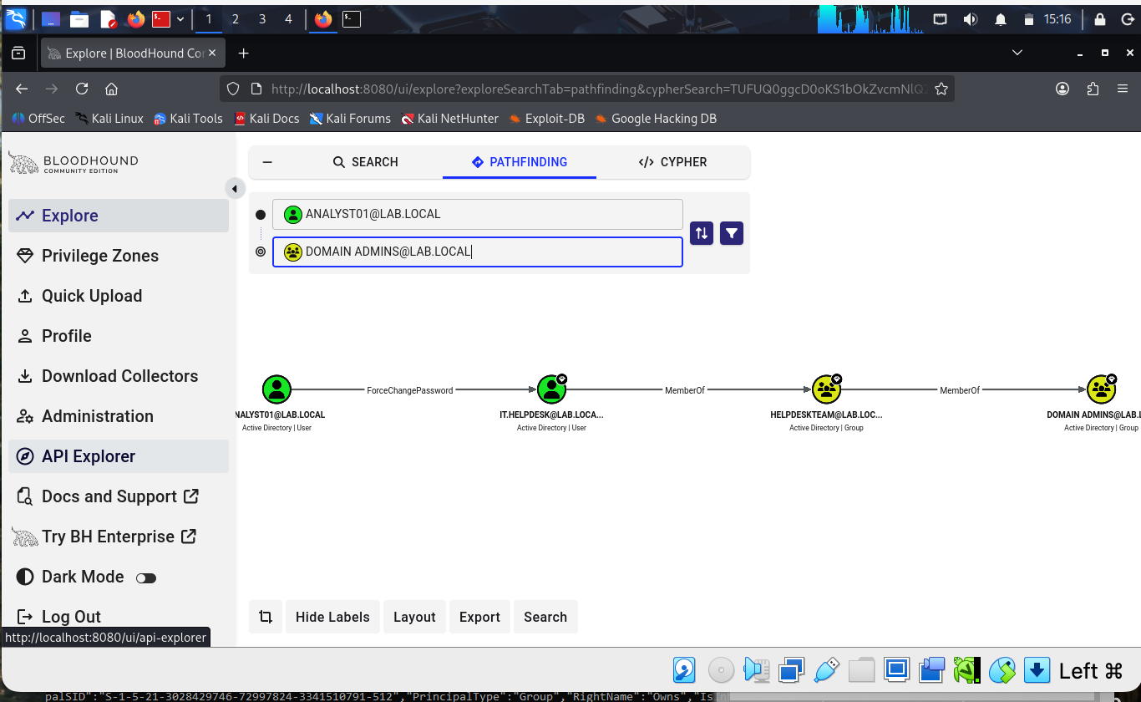
Figure 4 – The complete path: analyst01 → ForceChangePassword → it.helpdesk → MemberOf → Helpdesk Team → MemberOf → Domain Admins. The badges mark Tier Zero (high-value) objects.
Clicking any edge surfaces BloodHound’s built-in abuse and remediation guidance – the practical "so what" for each hop, including how an attacker would exploit it and how a defender detects and cuts it.
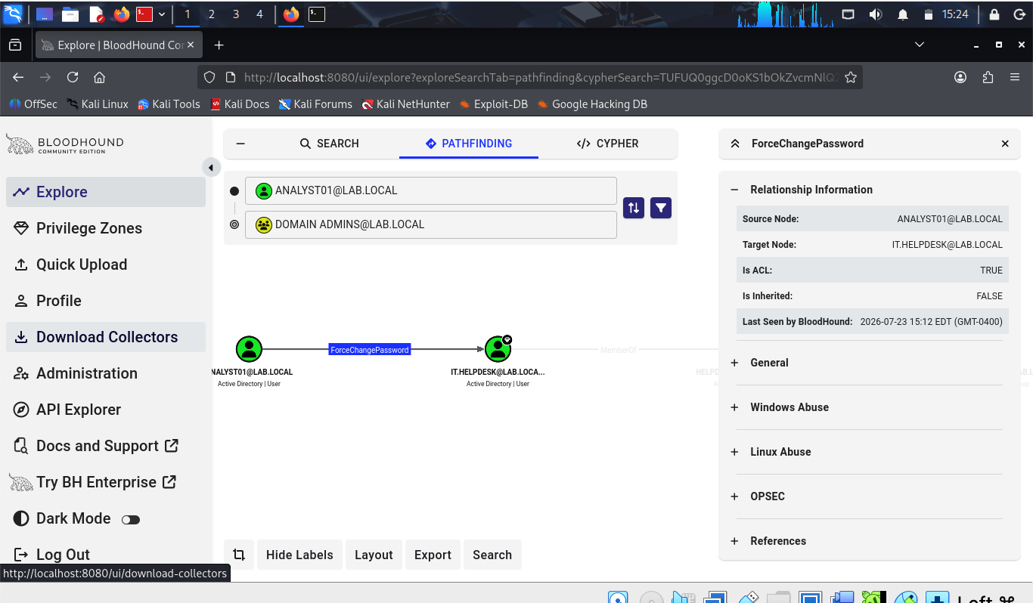
Figure 5 – Edge detail for ForceChangePassword, confirming it is an ACL-based relationship, with built-in abuse, OPSEC, and remediation references.

5. Challenges and How They Were Solved
In the interest of full transparency: this lab took considerably longer than anticipated. Importantly, the delays were not in the concept or the AD build – those went smoothly. Almost all the time was lost to environment and tooling instability. I am documenting these plainly because each one is a reusable lesson.

5.1 The root cause: memory starvation
The single biggest time sink was that the Kali VM was provisioned with only ~2 GB of RAM. BloodHound CE runs three services (the app plus two databases, one of them Neo4j, which is memory-hungry). Under that ceiling the stack would start, run briefly, then drop connections or fail to write ingested data into the graph. The symptoms were misleading – they looked like login or upload problems – which is why it took a while to trace back to memory.
Before (the problem) | After (the fix)
Total RAM: 1.9 GiB, ~800 MiB free | Total RAM: 3.8 GiB, ~2.3 GiB free
Swap heavily used; containers unstable | Swap at 0; all containers healthy and stable
Ingest accepted but never reached the graph | Ingest processed and persisted correctly

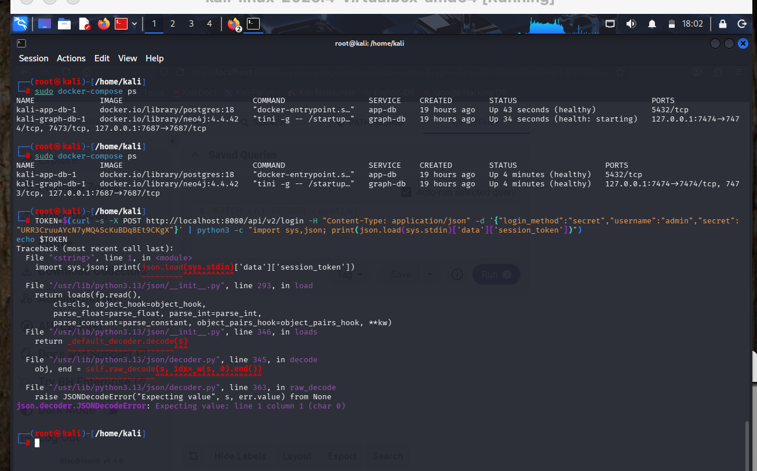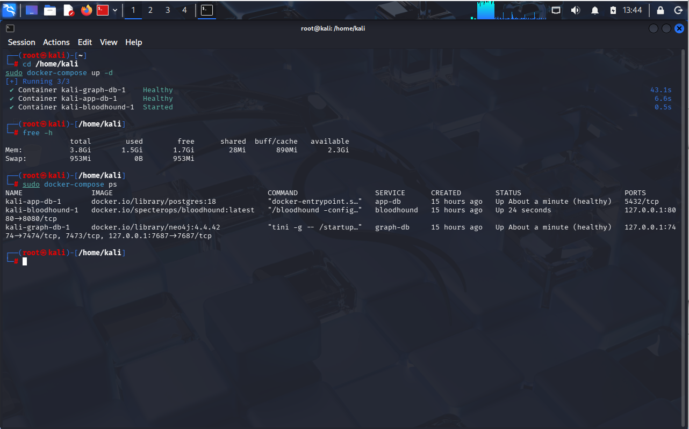
Figure 6 – Left: the diagnosis (1.9 GiB total, swap in use). Right: after raising the VM to ~4 GB, memory headroom restored and the stack healthy.
Fix: powered down the VM, raised its memory to 4 GB (and CPUs to 2), and kept the Windows VM off during analysis to free host memory. This was the turning point – nearly every downstream failure resolved once the stack had room to breathe.

5.2 A silent configuration rollback
The most subtle problem: after repeated VM resets and hard power-offs, the Windows domain quietly reverted to an earlier state that predated the ForceChangePassword permission. The group nesting survived, but the ACL did not. So every collection was technically "successful" yet missing the one edge that mattered, and the BloodHound graph kept coming back without the path. The breakthrough was querying the graph for edge types, realizing ForceChangePassword was simply absent, and then checking the source – the ACL was gone from AD itself.
Fix: re-applied the single ACL, verified it in AD, then verified it inside the freshly collected ZIP before transferring. Lesson: when a graph is missing an expected edge, check the source data first, not the tool.

5.3 Smaller frictions (each a quick lesson)
Challenge | Resolution / lesson
Endless login churn in BloodHound | Sessions/passwords reset repeatedly during troubleshooting. Lesson: set one memorable lab password early and record it.
File transfers repeatedly blocked (SmartScreen, wrong filenames) | Bypassed the browser entirely; pulled files over SSH/local HTTP on the isolated network. Lesson: never rely on drag-drop or browser downloads inside a locked-down VM.
Upload "accepted" but graph stayed empty | Turned out to be the memory issue (5.1) plus needing an explicit analysis trigger. Lesson: use verbose output to confirm HTTP responses instead of assuming success.

The honest headline
The security concept was the easy part. The hard part was operating a resource-constrained, repeatedly-reset lab. Adequate RAM, stable snapshots, verify-before-transfer, and recorded credentials turn a multi-day slog into a same-day exercise.

6. Why This Matters for Defenders
The offensive framing is only half the story. The same graph that shows an attacker a route up is a defensive asset, and arguably a more valuable one.

6.1 The blue-team case
- Finds what list-based reviews miss. Permission drift and nested-group risk are nearly invisible when auditing groups one at a time; they are obvious as a graph.
- Speaks to risk, not noise. "A single compromised low-privileged account can reach Domain Admins in three hops" is a sentence leadership understands and can prioritize.
- Measurable. The number of paths to high-value (Tier Zero) assets is a metric that can be tracked down over time – a concrete improvement story.
- Complements existing controls. It pairs naturally with vulnerability management and phishing-awareness work, adding the "what happens after initial access" dimension.

6.2 From a snapshot to continuous monitoring
A single BloodHound run is a point-in-time photograph. The more interesting direction is treating it as an ongoing control: recollect the graph on a schedule, compare each run to the last, and alert when a new path to a high-value target appears. In outline:
- Collect on a schedule – SharpHound as an automated task under a low-privilege service account.
- Ingest and analyze automatically – script the same API calls used manually in this lab.
- Diff against the previous run – flag any principal that gained a new path to a high-value asset.
- Alert and remediate – route new paths to wherever analysts already work, cut the offending edge, and re-measure.
This reframes the work from "penetration test" to continuous attack-path monitoring. Note that the commercial BloodHound Enterprise product is purpose-built for exactly this; the value of the community-edition approach is understanding the mechanics and approximating the core of it before deciding whether the enterprise tier is worth it.
A neat symmetry
SharpHound collection is itself something a strong detection capability should notice. So a continuous-monitoring job and a mature SOC’s detection are two sides of the same coin – one surfaces the paths, the other should catch the act of looking for them.

7. Conclusion and Next Steps
The lab achieved its goal: a complete, understood, and independently-verified AD attack path, collected and visualized end to end. Just as valuable, it produced a clear-eyed record of the environmental issues that slowed it down – issues that are entirely avoidable next time.
Natural next steps for the lab:
- Extend the attack-path skill set: a Kerberoastable service account (the HasSPN edge), which adds offline ticket cracking to the workflow.
- Prototype the continuous-monitoring loop from Section 6.2 against the lab domain.
- Practice remediation and re-measurement – cut a path, re-collect, and confirm it is gone.

Appendix – lab stack: VirtualBox on macOS; Windows Server 2022 (lab.local domain controller); Kali Linux 2025.4; BloodHound Community Edition v9.4.0 (Docker: app + PostgreSQL + Neo4j); SharpHound v2.13.0. Networking: host-only / isolated.

